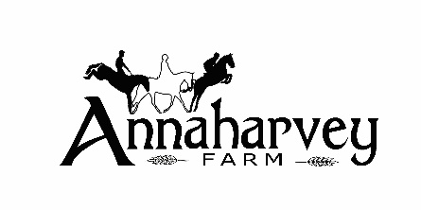

Child Safeguarding Statement

- Name of service being provided: Equestrian Centre, Horse Riding School and Accommodation Provider.

- Nature of service and principles to safeguard children from harm
Annaharvey Farm provides equestrian education for all levels of equestrian sport. Annaharvey farm is committed to safeguarding children and young people. All our staff working with children seek to create a safe environment for children and young people to participate in equestrian sport.

- Risk Assessment

We have completed a Safeguarding Risk assessment that indicates the areas of potential risk of harm, the likelihood of the risk occurring, and gives the required policy, guidance or procedure documents required to alleviate these risks. The list of risks identified are contained in the categories- Coaching/teaching practices, Complaints & Discipline, Reporting Procedures. Use of facilities, , Recruitment , Communications and General Risk of Harm.

- Procedures

Our Child Safeguarding Statement has been developed in line with requirements under the Children First Act 2015, Children First: National Guidance for the Protection and Welfare of Children (2017), and Tusla’s Child Safeguarding: A Guide for Policy, Procedure and Practice. In addition to the procedures listed in our risk assessment, the following procedures support our intention to safeguard children while they are availing of our service:

- Procedure for the management of allegations of abuse or misconduct against workers/volunteers of a child availing of our service;
- Procedure for the safe recruitment and selection of workers and volunteers to work with children;
- Procedure for provision of and access to child safeguarding training and information, including the identification of the occurrence of harm;
- Procedure for the reporting of child protection or welfare concerns to Tusla;
- Procedure for maintaining a list of the persons (if any) in the relevant service who are mandated persons;
- Procedure for appointing a relevant person.
All procedures listed are available upon request.
- Implementation

We recognise that implementation is an on-going process. Our service is committed to the implementation of this Child Safeguarding Statement and the procedures that support our intention to keep children safe from harm while availing of our service.

Signed: _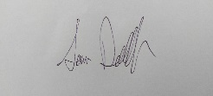 Manager
Sam Deverell – Annaharvey farm, Tullamore Tel. 0579343544 Email sam@annaharveyfarm.ie

For queries, please contact Sam Deverell or Ev Browne, Relevant Person under the Children First Act 2015.

